Lab 3 manual: Capacitors
Dr. D. Beznosko
3/31/2025
For PHYS 2212L only
(Lab outcomes: multiple measurements across physical system, linearization of the reciprocal fit and error bars handling. Using online fitting tool at https://sos.clayton.edu/physics/chi2/ or a backup option at http://www.physicsplot.com/)

Abstract
A capacitor is a device to store charge and energy in the form of the electric field. In this lab, we will explore the dependance of the main property of the capacitor – its capacitance – on the distance between the plates in the simplest geometric case. Conversion of the error bars when trying to linearize a plot will also be explored.

Introduction
Leiden jars were the first capacitors. Read more on the history, it’s exciting. There are many types of capacitors from air to foil to electrolytic and ceramic. Even the integrated circuits have tiny capacitors. Tiny in size, but what about their capacitance? A capacitor can be used in a large variety of circuits from the rectifiers to multiple uses in the AC circuits. Can you find a few of those? Where else capacitors can be used? Can we use them to power cars?

Experimental Setup
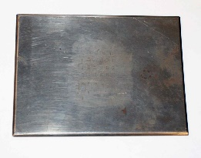
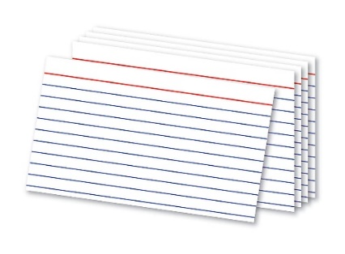
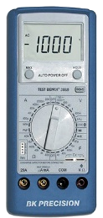
The setup in Figure 1 consists of paper index cards, two metal places and a multimeter with a capacitor probe input.
Multimeter with capacitance input
Metal Plates
Index cards
Figure 1: The experimental setup schematic. Two metal places and paper index cards are used to produce a capacitor. Connection wires and holding pins are not shown.

Procedure
The goal of the experiment is to find the dependance of capacitance on geometric parameters and the dielectric coefficient of the paper. For that, simple measurement will be performed as follows:
Stack all the index cards together. There should be 30 cards. Using caliper, measure the stack thickness at least at 10 different places. Don’t compress the paper hard when doing this. Find the total thickness of a single card with error (hint – remember what happens with error when it is divided or multiplied by a constant).Measure the width and heigh of the metal plates (we don’t need the thickness). Measure each at least 10 times along each dimension and include both plates into the measurement. Write all errors down and calculate the area of the plates. Remember to propagate all relevant errors using partial derivatives!
Place 5 cards between the metal planes and fix them together with the pins. Make sure that the holding pins (typically, clothes pins) are not shorting the plates with any metal parts they might have. Measure the capacitance. Move the connecting wires, measure again a few times. Remove the cards and separate the plates with maximum distance that the wires allow and measure again. What does this tell you about the measurement errors? Check the multimeter manual for the precision and use it as part of the error. Don’t separate systematic and statistical etc. but rather combine them in quadrature into a single error.
Measure capacitance for 10, 15 … 30 cards. You should end up with 6 data points.

Experimental Data
The results of the measurements should be organized as Table 1 or similar. Think about how to organize this table. The error can be listed in a different column or as value ± error unit. Don’t include all data values here, only relevant means, stdev etc. In some cases, individual data points are not needed, especially for computer-based labs. For this lab, there are only 6 data points to include all of them in your report. What is the distance error?
Table 1: Experimental data.
Distance, m | Distance error, m | Capacitance, nF | Capacitance error, nF

Provide description about each entry as needed, don’t just leave the table without text in this section. Organize well so that data takes up less space, but everything needed is included. You can choose to include measured variables description into the section text and use simplified descriptions for the table column headers, such as D for distance, C for capacitance, etc.

Theory
The relationship between the capacitance and the geometry of the plates is given by the following equations:
$$C_{0}=\frac{ε_{0}A}{d}\left(1\right)$$
where $C_{0}$ is the capacitance without any material between plates, $ε_{0}$ is the permittivity of free space ($8.8542∙{10}^{−12}\frac{C^{2}}{Nm^{2}}$, this is for your information, usually there is no need to include known constants into your report), A is the surface area of a plate of the capacitor, and d is the separation distance between the plates. If the space between the plates is filled with anything but vacuum, the equation changes:
$$C=κ\frac{ε_{0}A}{d}\left(2\right)$$
with $κ$ being the dielectric constant for the material. Note that for the air, $κ≈1.0006$ so we don’t consider air to be different from vacuum within our measurement precision.
Remember to include all relevant equations, like what are you plotting (that is, what is the slope from that), errors on any axes that need error propagation, $κ∧Δκ$ from slope, and so on.

Analysis
The analysis will have two plots. Show supporting calculations, etc.
For the first plot, we want to use equation 2 directly. Plot the measured capacitance vs. the reciprocal distance between the plates. Think about how the error for the distance will change here? (Hint: $\frac{1}{d}=f$ and you are looking for $Δf$ given $Δd$. Derivative is an answer). Do the linear fit using pol1 name for the function, remember to fill in the labels for the X and Y axes. As you include the caption for each figure, there is no need to do the plot title.
Find the quality of the fit from ${χ^{2}}/{ndf}$and convert it into probability using a tool at http://courses.atlas.illinois.edu/spring2016/STAT/STAT200/pchisq.html. Is your relationship linear? Use the slope (with error of course) to find $κ$. Propagate the error.
For the second plot, we want to get the dielectric constant for the paper directly as a slope. Take the ratio of eq. 2 over eq. 1 and show what $κ$ will equal to. Plot the measured capacitance vs. the calculated one using equation 1 for the same area and same distances between the plates. The slope of the line is what you seek. (This is a plot, what other things should be done? Axes labels, units, etc.) Try to find the dielectric constant of paper in some sources and compare with your result. Why is it not matching well? Is that only measurement errors or something else can be interfering? Hint – paper is not a name for a single material. Compare the results from both plots you have and the accepted value.

Conclusion
Comment on your result and the methods used to find it. What did you learn in performing this measurement? Where else can it be used? Can this experiment be improved?

References

[1] | PASCO Scientific, 10101 Foothills Boulevard, Roseville, California 95747 USA.

